SUSTAINABLE DEVELOPMENT GOALS 1 (ZERO POVERTY)

I chose this SDG because i feel like it affects us more in kenya and the world in general. we see this problem more in society and we interact with people facing this problem .

Definition of the SDG indicator: Indicator 1.1.1 is the “proportion of the population living below the international poverty line by sex,age,employment status and geographic location in the UN SDG framework.The international poverty line is defined as living on 3$ per day.
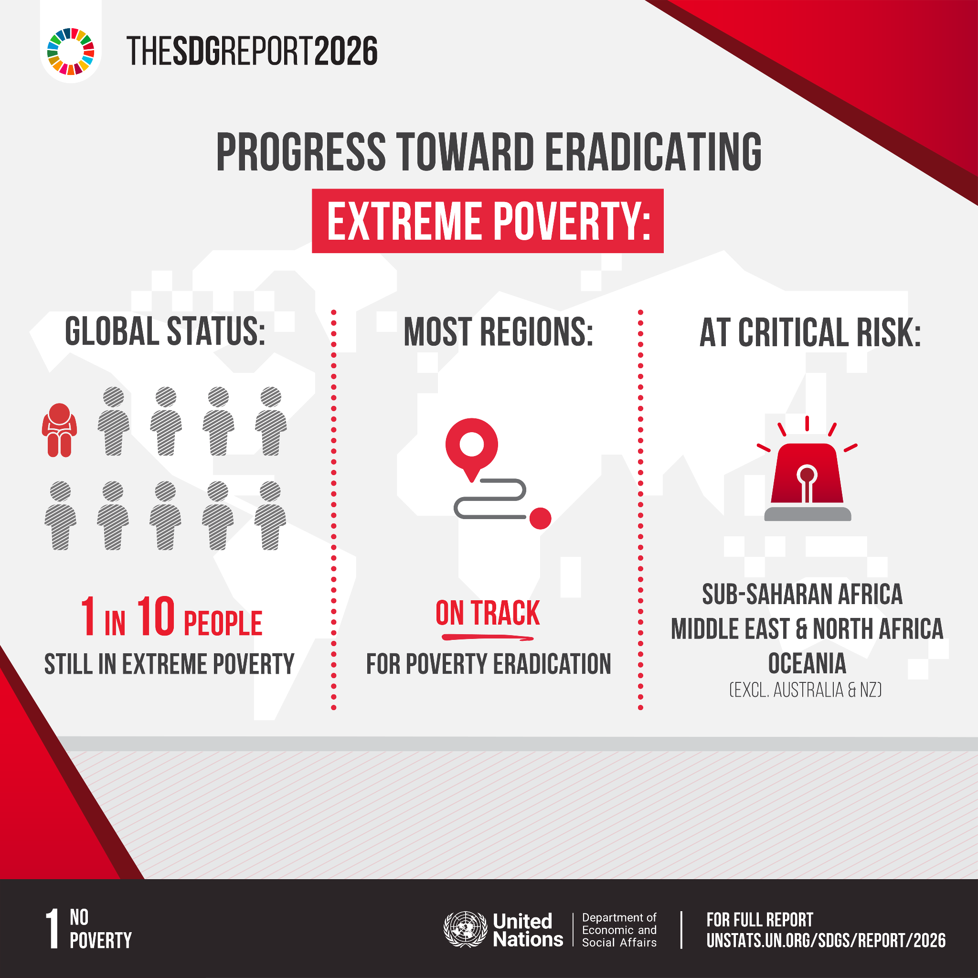
As per the latest SDG report on the subject , at least 1 out of 10 people in the world live in extreme poverty which shows it is very prevalent in our world as we know it.
The following is the link to my github repo where i did simple data analysis on a dataset containing 160 countries and their population living below poverty lines over the years :https://github.com/abelkk/SDG_1

REFERENCES:

https://ourworldindata.org/sdgs/no-poverty
https://sdgs.un.org/goals/goal1

